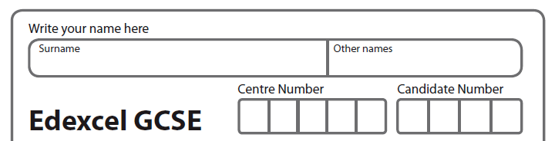

Mathematics A Paper 2 (Calculator) Higher Tier
PiXL Live Mock Paper
Time: 1hour 45 minutes

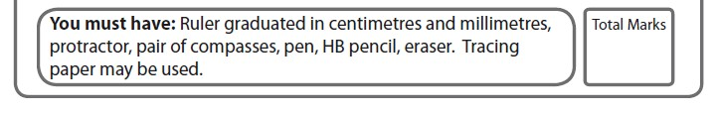

Instructions
t Use black ink or ball-point pen.
t Fill in the boxes at the top of this page with your name,
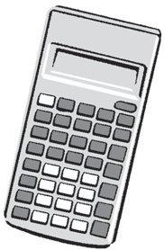
centre number and candidate number.
t
Answer all questions.
t
Answer the questions in the spaces provided
– there may be more space than you need.
t
Calculators may be used.
t
If your calculator does not have a n button, take the value of n to be
3.142 unless the question instructs otherwise.

Information
t The total mark for this paper is 100
t The marks for each question are shown in brackets
– use this as a guide as to how much time to spend on each question.
t
Questions labelled with an asterisk (*) are ones where the quality of your written communication will be assessed.

Advice
t Read each question carefully before you start to answer it.
t Keep an eye on the time.
t Try to answer every question.
t Check your answers if you have time at the end.

GCSE Mathematics 1MA0

Formulae: Higher Tier

You must not write on this formulae page.
Anything you write on this formulae page will gain NO credit.

Volume of prism = area of cross section × length Area of trapezium = 1
2

(a + b)h

a

cross section
h

b

Volume of sphere = 4 nr 3 Volume of cone = 1 nr 2h
3 3
Surface area of sphere = 4nr 2 Curved surface area of cone = nrl

r
l h

r

In any triangle ABC The Quadratic Equation
C The solutions of ax2 + bx + c = 0 where a i- 0, are given by

b a

A c B

−b ±
x =

(b2 − 4ac)
2a

Sine Rule a =
sin A
b
sin B
= c
sin C

Cosine Rule a2 = b2 + c2 – 2bc cos A

Area of triangle = 1
2

ab sin C

Answer ALL questions.
Write your answers in the spaces provided. You must write down all stages in your working.

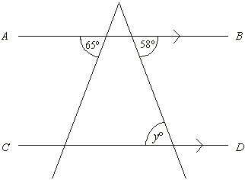
Q1.

Diagram NOT accurately drawn

AB is parallel to CD.

(i) Write down the value of y.

.......................

(ii) Give a reason for your answer.

.........................................................................................................................

(Total 2 marks)

Q2. (a) Use your calculator to work out the value of
45.6 × 123
0.342 − 0.282

Write down all the figures on your calculator display.

(2)

(b) Write your answer to part (a) correct to 3 significant figures

(1) (Total 3 marks)

Q3. (a) Simplify m + m + m + m

........................

(1)

(b) Simplify p × q × 4

........................

(1)

(c) Expand 5(3x – 2)

....................................

(1) (Total 3 marks)

Q4. Naomi wants to find out how often adults go to the cinema.

She uses this question on a questionnaire. “How many times do you go to the cinema?”

Not very often Sometimes A lot

(a) | Write down two things wrong with this question.
 | 1 ......................................................................................................................
 | .........................................................................................................................
 | 2 ......................................................................................................................
 | .........................................................................................................................
(2)

(b) Design a better question for her questionnaire to find out how often adults go to the cinema.
You should include some response boxes.

(2) (Total 4 marks)

Q6. On the grid. draw the graph of y = 2x -3 for values of x from -2 to 2.

y

5

4

3

2

l

3 -2 -l 0 l 2 3 X
l

2

3

A

5

t:.
v

7

8

(Total 3 marks)

Q6. This formula is used to predict the adult height of a baby girl.

H = 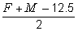

H = adult height of girl (cm)
F = height of father (cm)
M = height of mother (cm)

Karen and Keith have a baby girl.
They are interested in finding out how tall their baby girl is likely to grow. Karen has a height of 156 cm.
Keith has a height of 172 cm.

(a) Use the formula to predict the adult height of their baby girl.
Show clearly how you get your answer.

Height ..................................... cm

(2)

John and Jenny also have a baby girl. John and Jenny are the same height.

When they use the formula to predict the adult height of their baby girl they get an answer of 162 cm.

(b) Find an estimate of Jenny’s height.
Give your answer to the nearest centimetre.

Height ..................................... cm

(3) (Total 5 marks)

Q7.

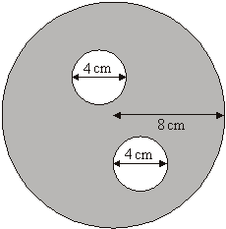

Diagram NOT accurately drawn

The diagram shows two small circles inside a large circle. The large circle has a radius of 8 cm.

Each of the two small circles has a diameter of 4 cm.

(a) Write down the radius of each of the small circles.

............................. cm

(1)

(b) Work out the area of the region shown shaded in the diagram.
Give your answer correct to one decimal place.

...................................... cm2

(4) (Total 5 marks)

Q8*. Nilmini is going to buy some grass seed.

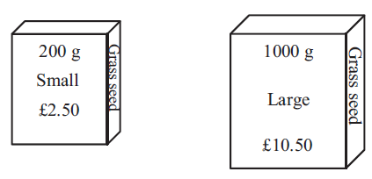

Grass seed is sold

in 200g boxes costing £2.50 each,

in 1000g boxes costing £10.50 each.

Which box of grass seed gives the better value for money? You must show all your working.

(Total 4 marks)

Q9. 10 students each took a French test and a German test. The table shows their marks.

French marks | 44 | 30 | 40 | 50 | 14 | 20 | 32 | 34 | 20 | 45
German marks | 48 | 35 | 45 | 54 | 18 | 22 | 36 | 38 | 25 | 50

(a) Complete the scatter graph to show the information in the table. The first 8 points in the table have been plotted for you.

German mark 60

×

50
×
×

40
×
× ×

30

×
20
×

10

0 10 20 30 40 50 60
French mark

(1)

(b) What type of correlation does this scatter graph show?

...........................

(1)

(c) Draw a line of best fit on the scatter diagram.

(1)

(d) Use your line of best fit to estimate

(i) the German mark for a student with a French mark of 26,

...........................

(ii) the French mark for a student with a German mark of 43.

...........................

(2)

(Total 5 marks)

Q10.

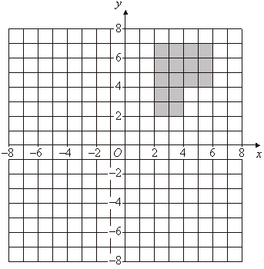

(a) Rotate the shaded shape 90° clockwise about the point O.

(2)

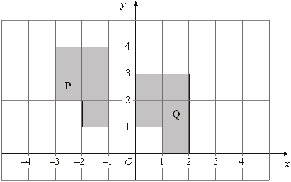

(b) Describe fully the single transformation that will map shape P onto shape Q.

.........................................................................................................................

(2) (Total 4 marks)

Q11. Barbara goes on holiday to Prague. The currency in Prague is the Koruna (KC).

This graph can be used to convert between £ (pounds) and KC (Koruna). The exchange rate is £1 = 30 KC.

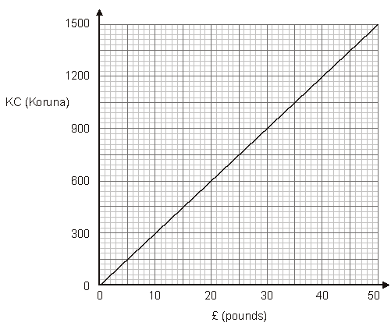

Barbara bought some things in London.
She saw the same things on sale in Prague.

The table shows the cost in £ (pounds) and the cost in KC (Koruna).

 | Cost in London  £ (pounds) | Cost in Prague KC (Koruna)
Item
Headphones | £15 | 450 KC
Suitcase | £34 | 750 KC
Music player | £26 | 810 KC

Barbara thinks the total cost of these things was more in London than in Prague.

Is she correct?
Give a reason for your answer. You must show all your working.

(Total 5 marks)

Q12. –2 < n ≤ 4
n is an integer.

(a) Write down all the possible values of n.

.........................................

(2)

(b) Solve the inequality 6x – 3 < 9

................................

(2) (Total 4 marks)

Q13. The equation

x3 + 20x = 71

has a solution between 2 and 3

Use a trial and improvement method to find this solution. Give your answer correct to one decimal place.
You must show ALL your working.

x = .........................

(Total 4 marks)

Q14. The probability that a seed will grow into a flower is 0.85.
Loren plants 800 seeds.

Work out an estimate for the number of these seeds that will grow into flowers.

.................................

(Total 2 marks)

Q15. The table shows information about the number of hours that 120 children used a computer last week.

Number of hours | Frequency
0 < h ≤ 2 | 10
2 < h ≤ 4 | 15
4 < h ≤ 6 | 30
6 < h ≤ 8 | 35
8 < h ≤ 10 | 25
10 < h ≤ 12 | 5

Work out an estimate for the mean number of hours that the children used a computer. Give your answer to 2 decimal places.

..................................... cm

(Total 4 marks)

Q16. The length of a rectangle is 30cm, correct to 2 significant figures.

The width of a rectangle is 18cm, correct to 2 significant figures.

(a) Write down the upper bound of the width.

…………………………………

(1)

(b) Calculate the upper bound for the area of the rectangle

……………………………………….

(2) (Total 3 marks)

Q17.

Diagram NOT
accurately drawn

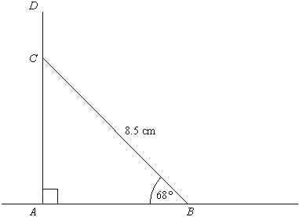

The diagram represents a vertical pole ACD.
AB is horizontal ground.
BC is a wire of length 8.5 metres.

The height of the pole AD is 9 metres.
For the pole to be correctly installed, the length DC has to be at least 1 metre. Show that the pole has been correctly installed.

.....................................

(Total 4 marks)

Q18.

Triangles ABC and DEF are similar.

AB = 4cm. AC = 9cm. DE = 6cm.
EF = 10.5cm.

B

E Diagrams NOT
accurately drawn

4 cm
6 cm
10.5 cm

A C D F
9 cm

(a) Work out the length of DF.

……………………………………….

(b) Work out the length of BC
(2)

……………………………………….

(2) (Total 4 marks)

Q19. Kylie wants to invest £20 000 for 3 years.

She considers two investments, Investment A and Investment B.

Investment A

£20 000

Earns 3.02% interest per annum

Interest paid yearly by cheque
Investment B

£20 000

Earns 2.98% compound interest per annum

Kylie wants to get the greatest return on her investment.

Which of these investments should she choose?

.....................................

(Total 6 marks)

Q20.

y @".7,.A 78$
Q .++<,.$&>B!-,.*)

P
x

"!"#!$%&!'(")$!*"$%!+((,-").$&#!/01!234
#!"#!$%&!'(")$!*"$%!+((,-").$&#!/251!$34
9
6%&!7,.-"&)$!(8!"#!"#! 0
:(,;!(<$!$%&!=.><&!(8!$4

k = …………………………………..
(Total 3 marks)

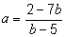
Q21. Make b the subject of the formula

.......................................................

(Total 4 marks)

Q22. Solve 3x2 + 2x – 4 = 0

Give your answer correct to three significant figures.

.....................................

(Total 3 marks)

Q23. The table below shows the population of each of three villages.

Village | Population
Ashley | 243
Brigby | 370
Irton | 127

Mr Akhtar carries out a survey of the people living in these three villages. He uses a sample stratified by village population.

There are 50 people from Brigby in his sample.

Work out the number of people from Irton in his sample.

.................................................................

(Total 2 marks)

Q24.

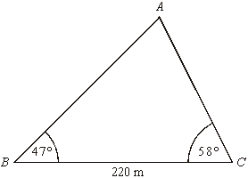

Angle ABC = 47° Angle ACB = 58° BC = 220 m
Diagram NOT
accurately drawn

Calculate the area of triangle ABC.
Give your answer correct to 3 significant figures.

.....................................

(Total 5 marks)

Q25. Sally has a bag of 9 sweets. In the bag, there are

3 orange flavoured sweets,

4 strawberry flavoured sweets and 2 lemon flavoured sweets.

Sally takes, at random, two of the sweets. She eats the sweets.

Work out the probability that the two sweets Sally eats are not of the same flavour

……………………………………….

(Total 4 marks)

Q26*.

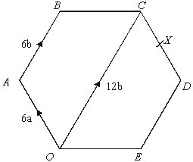

The diagram shows a regular hexagon OABCDE. = 12b

(a) Find , in terms of a and b.

.....................................

(1)

X is the midpoint of CD.
Y is the point on BC extended, such that BC : CY = 3 : 2 (b) Prove that O, X and Y lie on the same straight line.

(4) (Total 5 marks)

